

IT Management System

System Design Document

Latest Revision: 05/06/2022

# 

# 

# System Architecture

This system is separated into two components: The software application used by high permission level internal parties in order to access and modify relevant information for the business, and the web application provides other employees with the ability to submit tickets regarding maintenance and view relevant information.

**Desktop Application**

**Software Modules**This software is composed of a client-side application where users can access and modify information about their businesses and their assets from both a management perspective and an employee perspective with different permissions assigned to each role.

**Hardware Modules**

This application is designed to run on a computer running Windows 10 and above.

**The User Interface Modules**

* This application consists of a series of panels that provide users with access to various different components within the IT management system.
* The **Login** panel provides employees and management with the ability to log in with their own credentials, preventing people with insufficient permissions from accessing private data.
* The **Equipment** panel provides employees with the ability to check equipment in and out while also allowing management to append or remove equipment from this stack.
* The **Tickets** panel allows the user to view all issue tickets submitted by staff and allows them to be sorted by priority, category, and user.
* The **Employees** panel provides information about each employee, including the equipment they’ve checked out, their IDs, timecard information, etc;

**Interfaces to External Systems**

The desktop client requires access to an external database in order to both retrieve and update information regarding tickets, employees, and other business information. The intended database for this use case is handled through Amazon Web Services (AWS).

**Web Application**

**Software Modules**

This part of the project contains the web client that is used by general employees of the company. It was developed using HTML, CSS, Javascript, and PHP. Its main purpose is to provide employees with an interactive interface to communicate with management and/or the IT support team and view tickets.

**Hardware Modules**

This web application is designed under the assumption that the user is accessing it through a desktop browser.

**The User Interface Modules**

* The **Submission Form** consists of:
  + The **Employee ID** field serves as the main means of maintaining a unique identifier for the customer and is a required field. This, along with the **First Name** and **Last Name** fields, are automatically populated based on the credentials provided during login.
  + The **Short Description** text box allows the customer to enter a short description of the issue to be addressed.
  + The **Long Description** text box serves as the main point in which the customer can go further into detail and describe the issue that is to be addressed.
  + There are **Dropdown Lists** to help categorize and specify the customer’s issue: **Ticket Category (such as New Equipment Request, Software Issue, and Damaged Equipment)**, **Issue Scope (individual, team, departmental, or larger)**, **Ticket Classification, etc.**
* The **Ticket View** consists of a grid view where the user is able to see information regarding all tickets associated with that user

**Interfaces to External Systems**

The web client requires access to an external MySQL database (which was set up using AWS RDS) to both retrieve and store ticket information, as well as to verify login credentials. The web client is hosted on an AWS EC2 instance in order to be accessed remotely through the web on any device with access to the Internet. It is used to update information regarding customer tickets, which will then be retrieved and potentially updated through the desktop client’s access to the data.

# 

# Hardware, Software, and System Requirements

**Desktop Application**

**Hardware Requirements:**

RAM: 2 GB RAM

Storage: 1GB

Network: Broadband Internet connect

**Software Requirements:**

Python 3

**System Requirements:**

Windows 10/11

**Web Application**

**Hardware Requirements:**

Network: Broadband Internet connect

**Software Requirements:**

Web Browsers: Google Chrome, Firefox, Safari, Microsoft Edge, etc.

Python 3, HTML 5, CSS

**System Requirements:**

Windows 10/11, Linux, MacOS

# 

# External Interfaces

**AWS**:

AWS is the host for the database to store the information for our application.

<https://docs.aws.amazon.com/rds/index.html>

<https://docs.aws.amazon.com/AmazonRDS/latest/UserGuide/Welcome.html>

**FuzzyWuzzy**:

The library searches for matches and near-matches of a given text and allows us to create a search functionality within the application.   
<https://pypi.org/project/fuzzywuzzy/>

**bCrypt:** Encrypts data sent between Desktop Client and RDS database  
 <https://pypi.org/project/bcrypt/>

**Tkinter:**

Provides essential tools for constructing the user interface  
 <https://docs.python.org/3/library/tkinter.html>

**Paramiko:**

Utilized to establish a connection between the desktop client and the EC2 instance  
 <https://www.paramiko.org/>

**Pillow:**

Used to display image attachments associated with tickets.  
 <https://python-pillow.org/>

**PyMySQL**:

PyMySQL allows us to connect to a SQL database.

<https://pypi.org/project/PyMySQL/>

# 

# Software Design

**Class Diagrams**

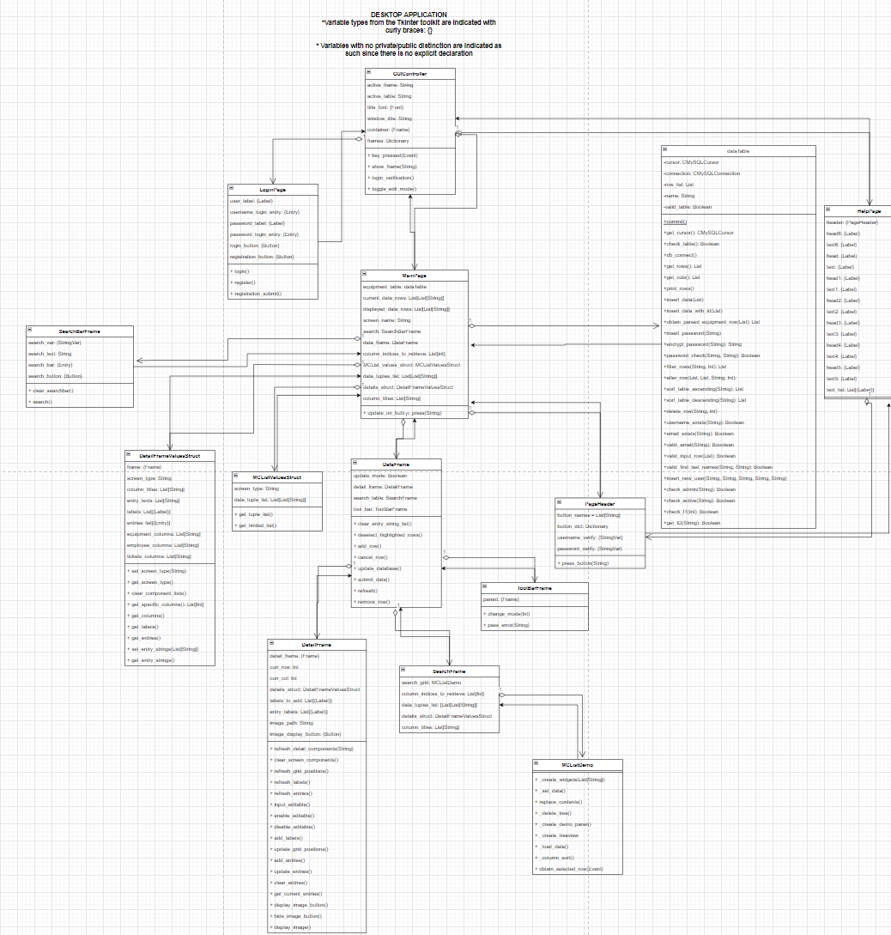

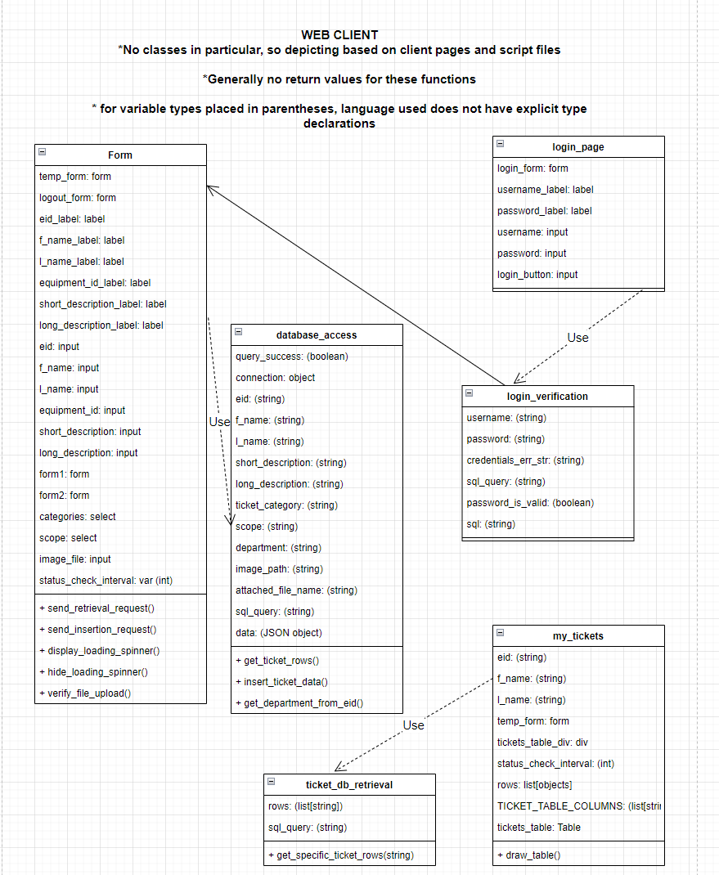

**\***Link to view the UML diagrams in larger size

[**https://tinyurl.com/2kdwr8tb**](https://tinyurl.com/2kdwr8tb)

**Interaction Diagrams**

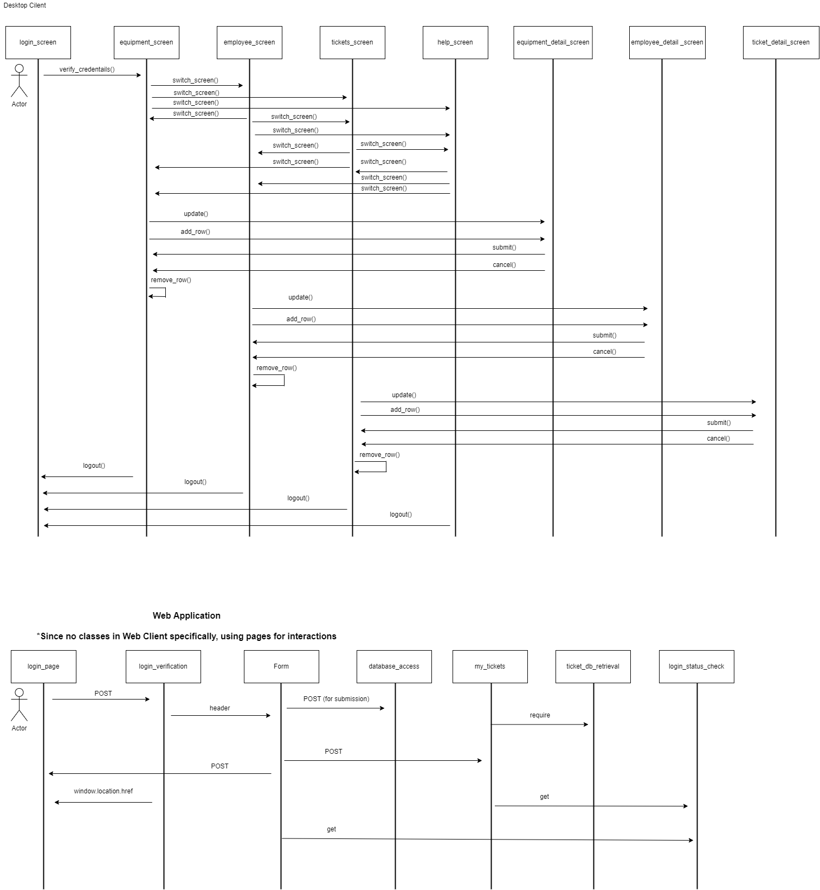

*Link to view the interaction diagrams in larger size

[**https://tinyurl.com/6z9zvykr**](https://tinyurl.com/6z9zvykr)

**Design Considerations**

*Design Principle***:** Accommodate Change

In designing the overall structure of the system, being able to accommodate for

the change in the application’s need of various business information details and

components was taken into consideration. For example, while the IT ticketing

system is a significant feature, a business’s management may want to incorporate

other management options to improve workflow.

*Design Principle*: Design for Testability

The idea behind the splitting of the system into three main components (database,

desktop client, and web client) is that they can easily assist in the testing of each

other’s functionality. For instance, the web application’s main purpose is to create a

ticket, which can then be checked through the database for actual updates in the

data. Furthermore, this can be confirmed through the desktop client’s pulling of

data from the database, and the desktop application’s functionality of making

changes to the central data can be checked back through the database as well.



# User Interface Design

**Desktop Client**

**Login Screen**

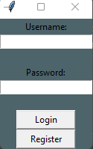

This screen serves the purpose of allowing the user to login.

* **The Username Box** allows the user to enter their email address.
* **The Password Box** allows the user to enter their password.
* **The Register Button** validates the information entered by the user and grants them access into the main application if the login information is correct and they are an authorized user
* **The Register Button** opens up a window that allows the user to create a new inactive account

**Database-connected Screens (Equipment, Employees, Ticketing from IT Perspective)**

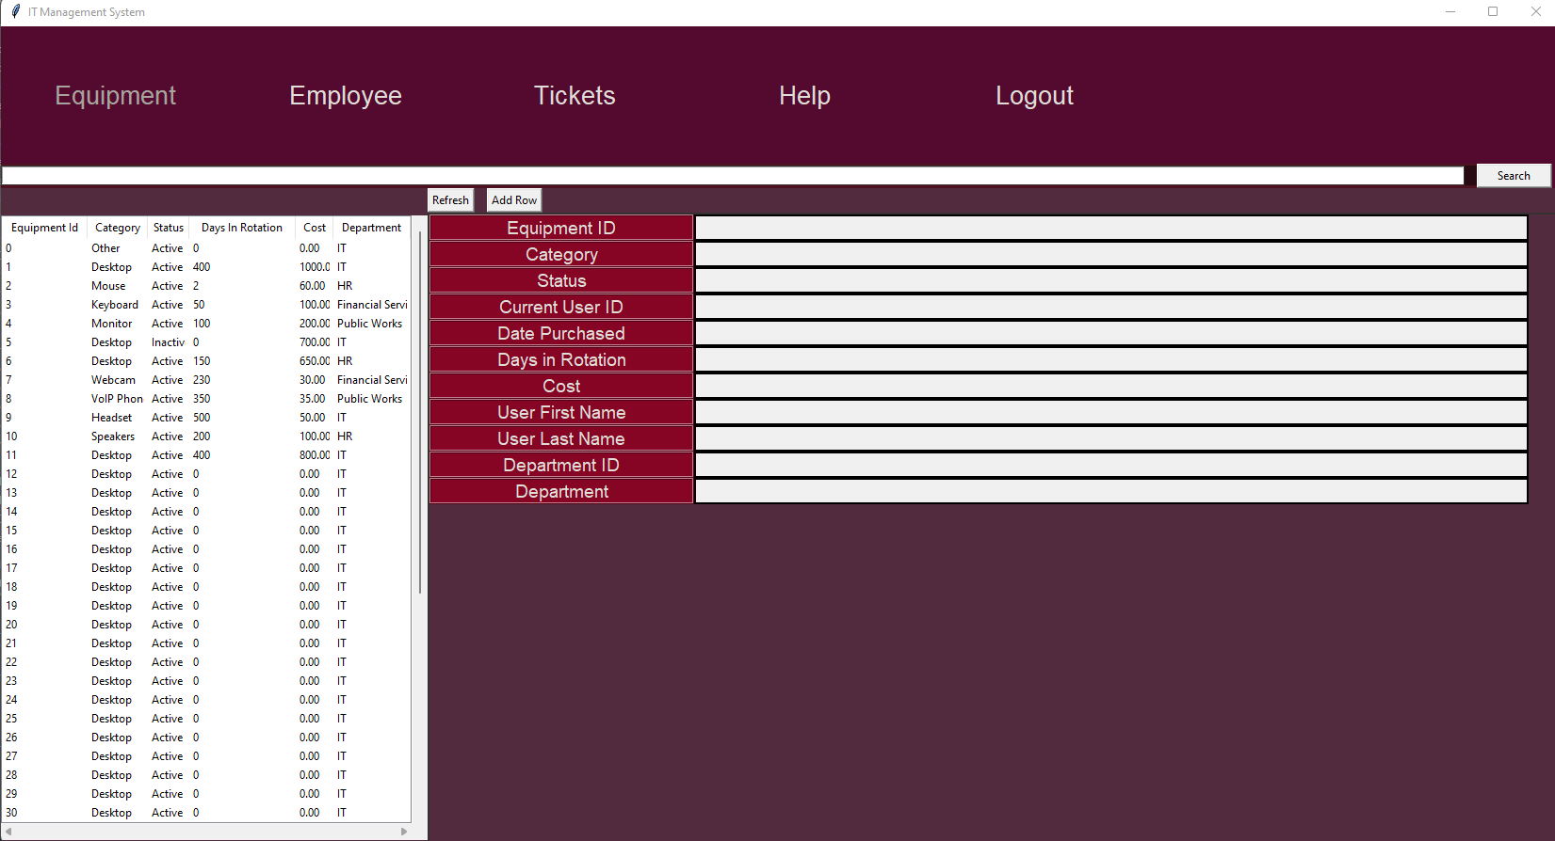

The Database Screens allow the user to see a variety of information about the assets and employees that a business has and make modifications to that data.

* **The Tab Buttons** allows users to select which information they want to view or modify. These are labeled as Equipment, Employees, Ticket, etc.
* **The Search Bar** allows users to try to find an item within the list view based on a fuzzy searching algorithm by typing in either a keyword or item name. The user can then click on the **Search Button** and receive a reduced list based on the criteria provided in the search.
* **The Table Grid** shows users a list of item boxes based on the contents of the search bar.
* **The Toolbar** consists of multiple buttons that allow users to perform edit operations on the currently selected row such as add, update, refresh, remove, etc;
* **The Details View** provides users with more information about the current row than is available immediately within **The Table Grid**

**Web Client**

**Login Page**

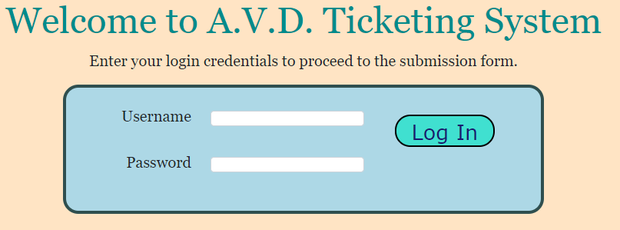

The Login Page contains two user input fields for the username and password. This page verifies that both a valid username and password are provided in order to proceed to the next screen when the login button is clicked. If invalid credentials are provided, the user will be redirected to this screen.

**Ticket Screen**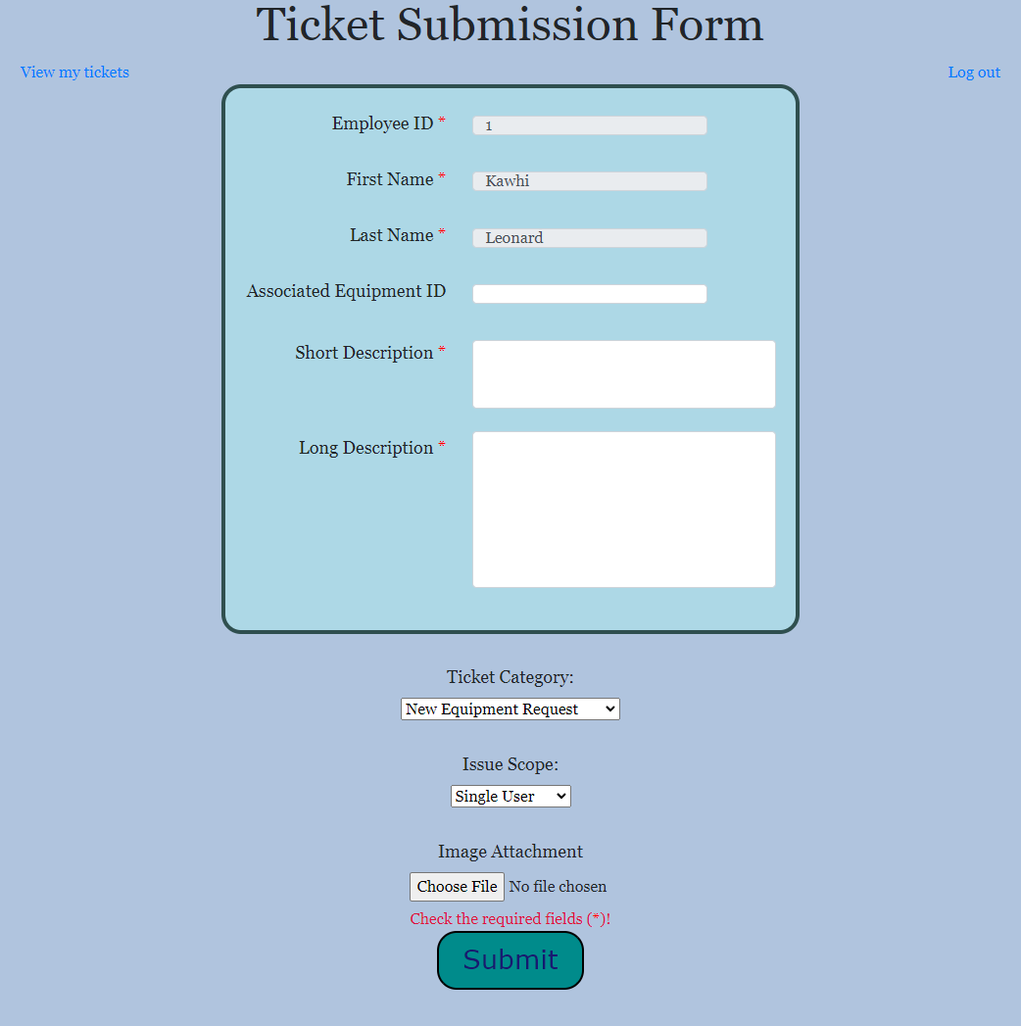

The Ticket Screen provides users with an interface to submit tickets regarding any issues they may be experiencing.

* **The Employee ID, First Name, and Last Name fields** are automatically populated based on the user credentials provided at the login screen. These are uneditable.
* **The Associated Equipment ID field** allows for the user to optionally provide an equipment ID that may be involved in the issue at hand.
* **The Short Description and Long Description fields** are text boxes that can be used to provide an explanation of the issue at hand. Short Description is meant for a brief idea of the problem, while Long Description is meant to be used as an in-depth explanation point.
* **The Ticket Category and Issue Scope fields** are dropdown lists that provide the employee with predetermined options pertaining to information regarding the issue. Ticket Category is used to group the ticket based on certain qualities of the problem, while Issue Scope is meant to represent the amount of people affected.
* **The Image Attachment field** allows the user to select an image file to upload as part of their ticket. There are checks in place to confirm that the size of the file stays below 3MB and that the file is of one of these types: JPG, JPEG, PNG.
* **The user feedback message** (as indicated in red above) displays any message that needs to be conveyed, such as a ticket submission attempt failing or succeeding.
* **The Submit Button** is used to actually proceed with the submission attempt. This button triggers checks to determine if the ticket submission was successful.

**My Tickets View**

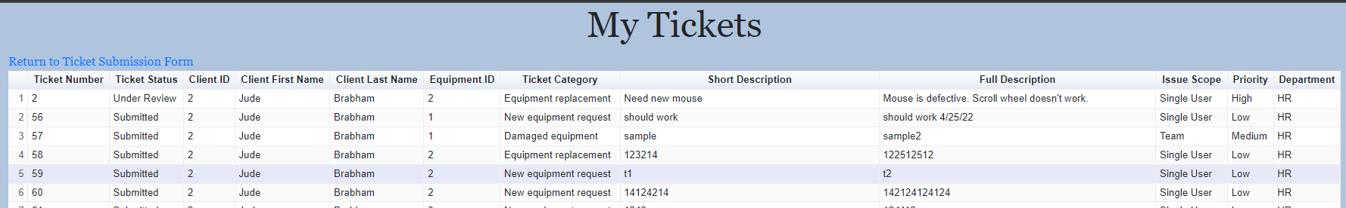

The My Tickets View is provided to show the tickets submitted for the user currently logged in. It displays each ticket as a row of fields as shown above and can be sorted by field values.

# 

# Glossary of Terms

**Application (n.)**

A program that runs on a computer. Software applications run on the desktop while web applications run on a browser.

**AWS (n.)**

**[Amazon Web Services]** Services provided by Amazon to handle operations including database management and remote server maintenance

**Dropdown List (n.)**

A user interface component that allows the user to select an option from a list that is revealed to the user upon clicking on a labeled button.

**Incident (n.)**

A ticket type in which the user is experiencing a problem (as opposed to a request). For example, an internet outage issue is classified as an incident.

**IT Team (n.)**

The individual or group of individuals responsible for the maintenance of data stored within this application.

**Log in (v.)**

Entering username and password credentials for the purpose of only allowing users with a sufficient permission level to access the data available to those at that level.

**Management (n.)**

High-level parties who are responsible for the assets and processes that occur within an organization.

**Panel (n.)**

A user interface component that represents everything visible to the user at a specific point in time.

**Permission Level (n.)**

A value that represents the amount of information that a specific user has access to. A higher permission level indicates that the user has access to more data and vice versa.

**Perspective (n.)**

Describes what each user sees within the software application. Users with a higher permission level have a wider perspective than users with a low permission level.

**Request (n.)**

A ticket type in which the customer needs an additional service; for instance, requesting upgraded equipment classifies as a request.

**Ticket (n.)**

A document submitted by a employee within the organization that references a specific issue said-user may be having with an asset or process within that organization.

**Ticket Scope (n.)**

The range of impact in which the issue has on a customer/user-base. For example, a scope value of “departmental” indicates that the issue affects the department as a whole and is therefore more serious than a ticket labeled with a scope of “individual”.

**User (n.)**

Any individual that utilizes the functionality offered by this application.

# 

# References

Okyol, O. (2020, August 4). *Using AWS RDS and python together*. Towards Data

Science. Retrieved February 7, 2022, from https://towardsdatascience.com/using-aws-rds-and-python-together-5718a6878e4c.

*Principles of Software Design*. GeeksforGeeks. (2020, June 17). Retrieved February 7,

2022, from https://www.geeksforgeeks.org/principles-of-software-design/

*Python tkinter tutorial*. GeeksforGeeks. (2021, March 28). Retrieved February 7,

2022, from https://www.geeksforgeeks.org/python-tkinter-tutorial/.